How to set up an autoship with Lifes Abundance for the cat food.

Click on the link below. It should be a hot link, and if not, just type it into the address bar on your device.

It is also found on all my emails that we have written back and forth and should be hot so you do not have to type it in.

[www.worldsbestpetfood.info](http://www.worldsbestpetfood.info)

You will see some type of welcome page. It may not look just like this but at the top you will see the same information.:

Next click on Poducts and there will be a dropdown window.

Choose Cat Food & this will appear:

Looking at the top row you have grain free and All Life Stages cat food, as well as the Healthy Start packs.

I have used both grain free and the normal & they like both. It is your choice on which to use.

You can change at anytime because you will be in control of your account.

They also have fish oil, which I like to add to the canned meat food that you will be using. However, LA will not have any more in stock until this December so you will have to find another source of a quality canned food. Once their brand returns, you can add that to your order and the shipping fees should not change no matter how much you order.

So. Lets say you choose the first choice and go with Grain Free.

It goes to this page and this is where you choose quantity.

Just below that has a square that says “ I want to sae $3.25”

Check that box then Add To Bag.

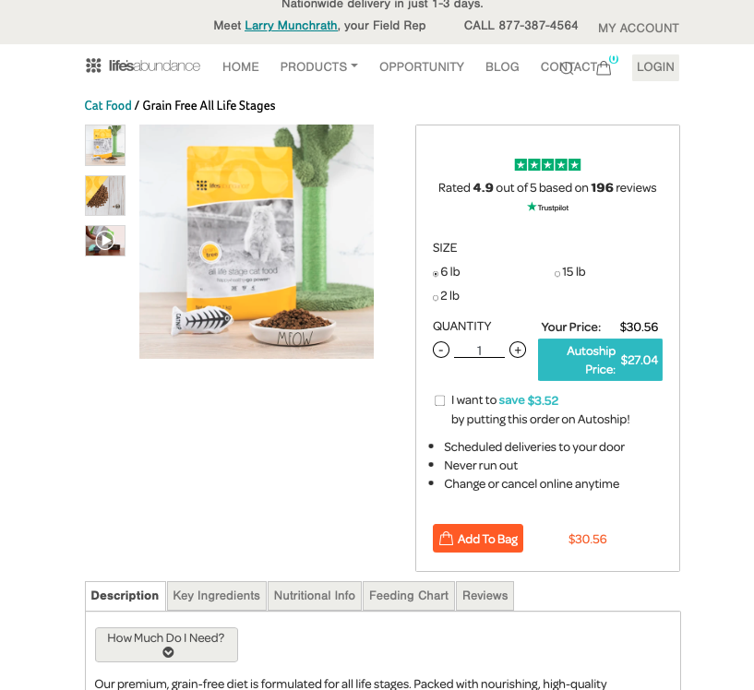

Once you do that you get another window that says it was Successfully Added to Bag.

Then it give you a choice to Continue Shopping.

There you can add the fish oil or any other thing you want.

Then choose ‘View Bag/Checkout’

It updated your basket and goes to this window where you will choose the Autoship Schedule. Bottom left.

This is the option once the dropdown window appears.

If you are getting the smaller 6# bag, start with 4 weeks.

You can change that to sooner or later as needed.

Then your basket is Updated, then click Checkout under order summary.

The next window is where you create your account.

It is for New Users (on the right side of the page)

Then you can create your account and choose the log in information.

Let me know if you have any questions or need more assistance.

The number for Lifes Abundance support or questions is 877.387.4564

Larry